CaseManagement_CreationOfCase_Instance23_03-Aug-2018_06-05-57_AM_SingleSignOn.png

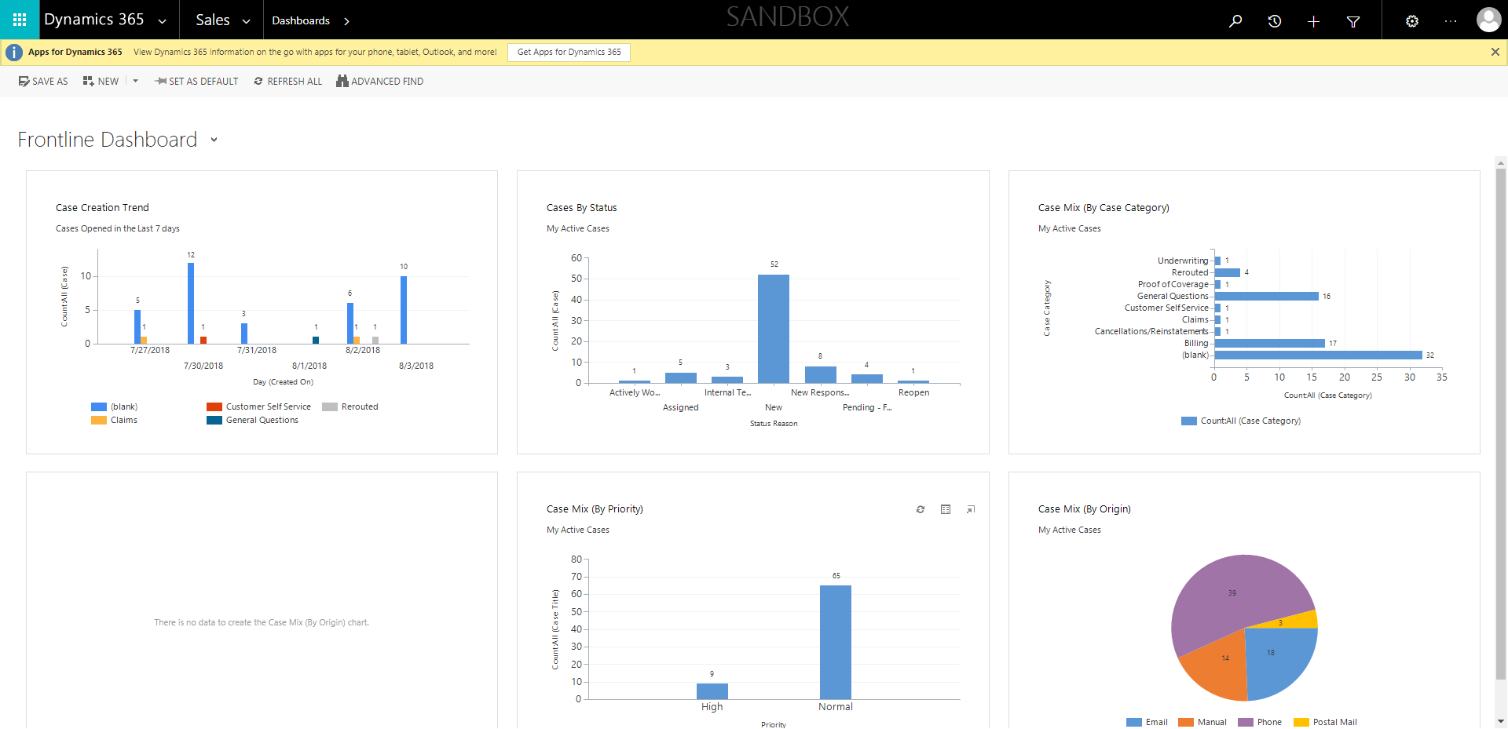

CaseManagement_CreationOfCase_Instance23_03-Aug-2018_06-05-25_AM_MouseClickActiononStaleElement.png

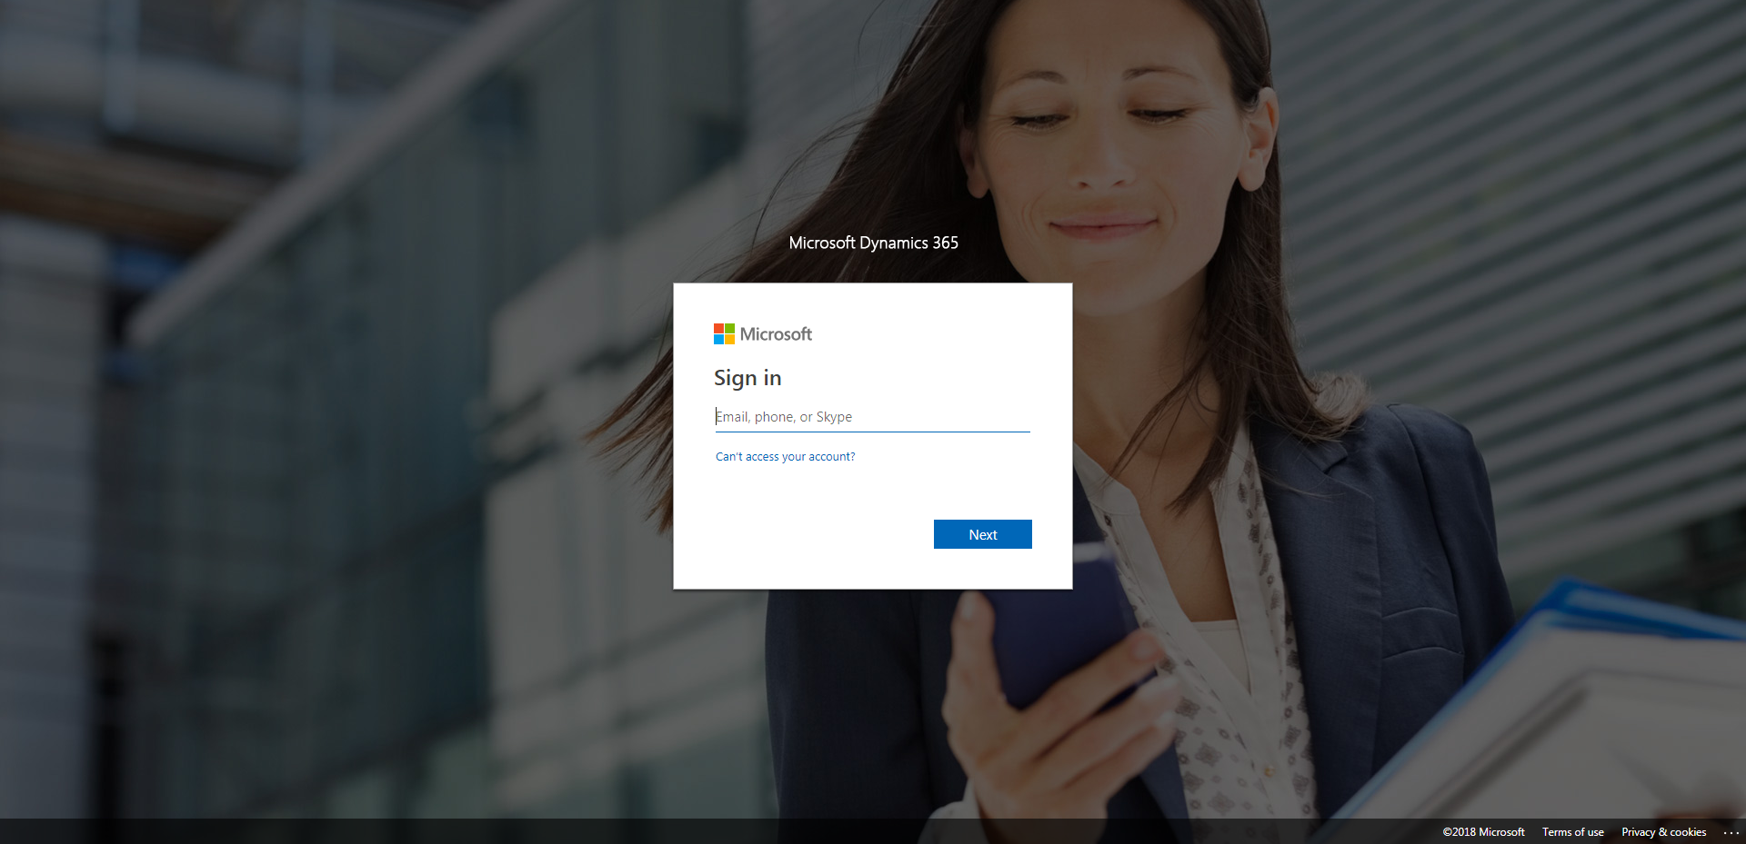

CaseManagement_CreationOfCase_Instance23_03-Aug-2018_06-07-49_AM_GetTextFromElement.png

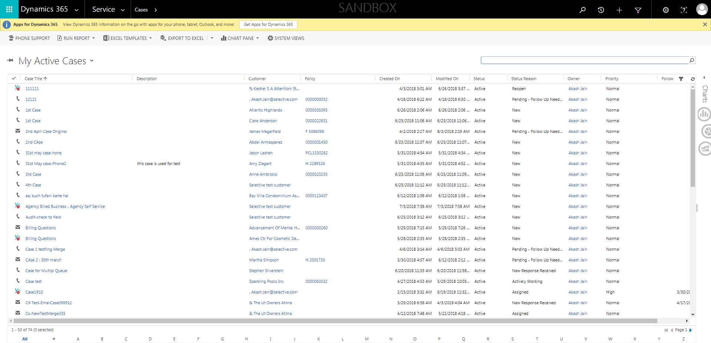

CaseManagement_CreationOfCase_Instance23_03-Aug-2018_06-05-27_AM_EnterTextAction.png

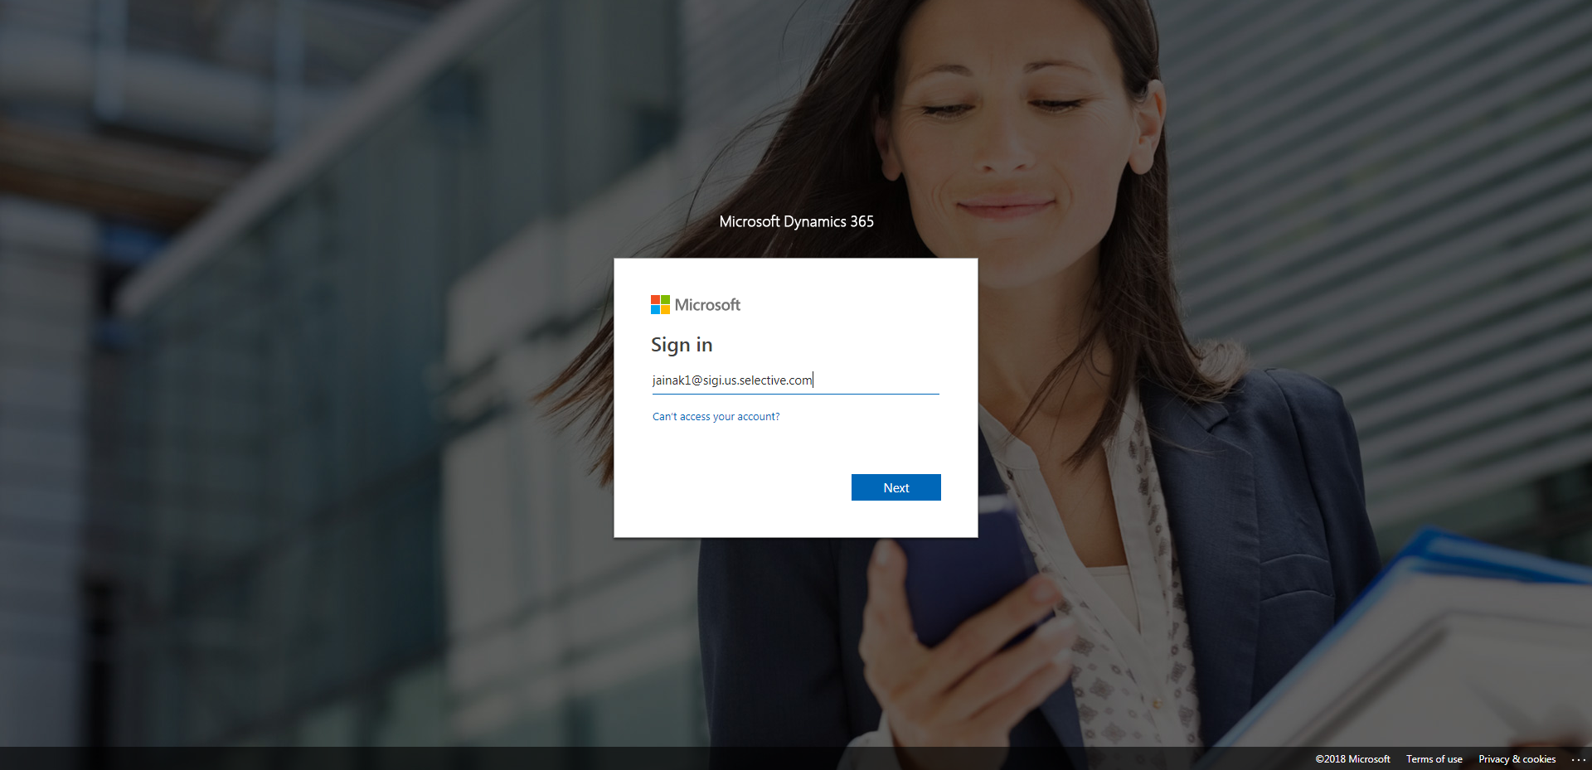

CaseManagement_CreationOfCase_Instance23_03-Aug-2018_06-06-53_AM_MouseClickActionMoveToElementBycssSelectorspanTabCS.png

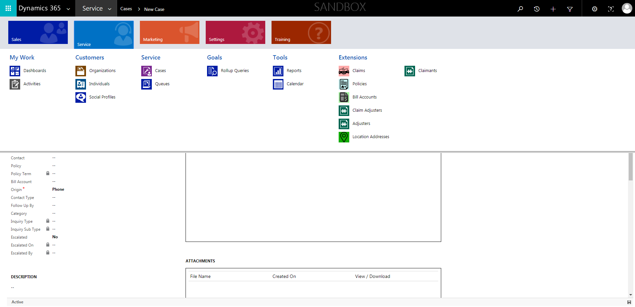

CaseManagement_CreationOfCase_Instance23_03-Aug-2018_06-11-59_AM_VerifyNewCaseCreationHouronCaseisinEasternTime.png

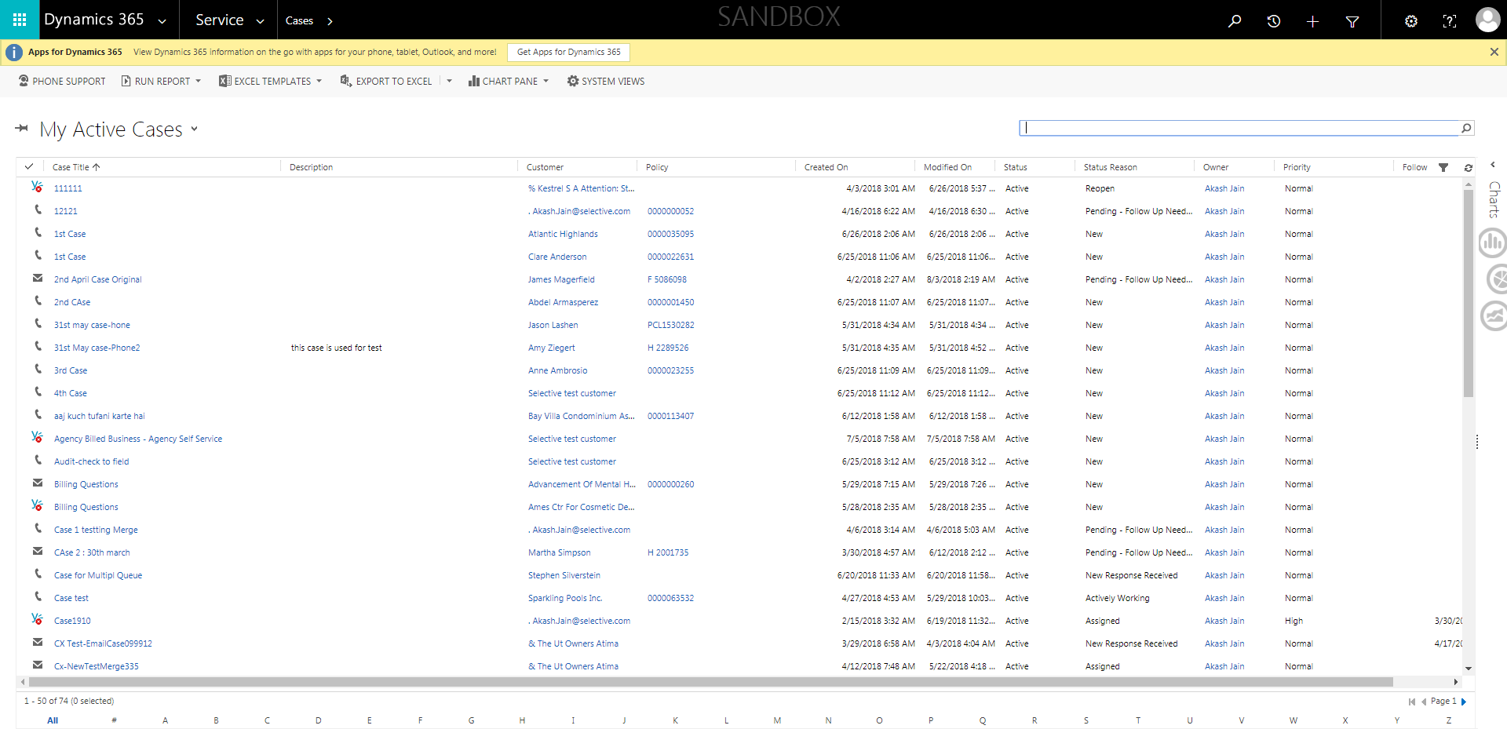

CaseManagement_CreationOfCase_Instance23_03-Aug-2018_06-07-50_AM_VerifyNewCaseCreationHouronCase.png



CaseManagement_CreationOfCase_Instance23_03-Aug-2018_06-06-57_AM_ValidatingCaseentitynavigation.png



CaseManagement_CreationOfCase_Instance23_03-Aug-2018_06-05-54_AM_SingleSignOn.png

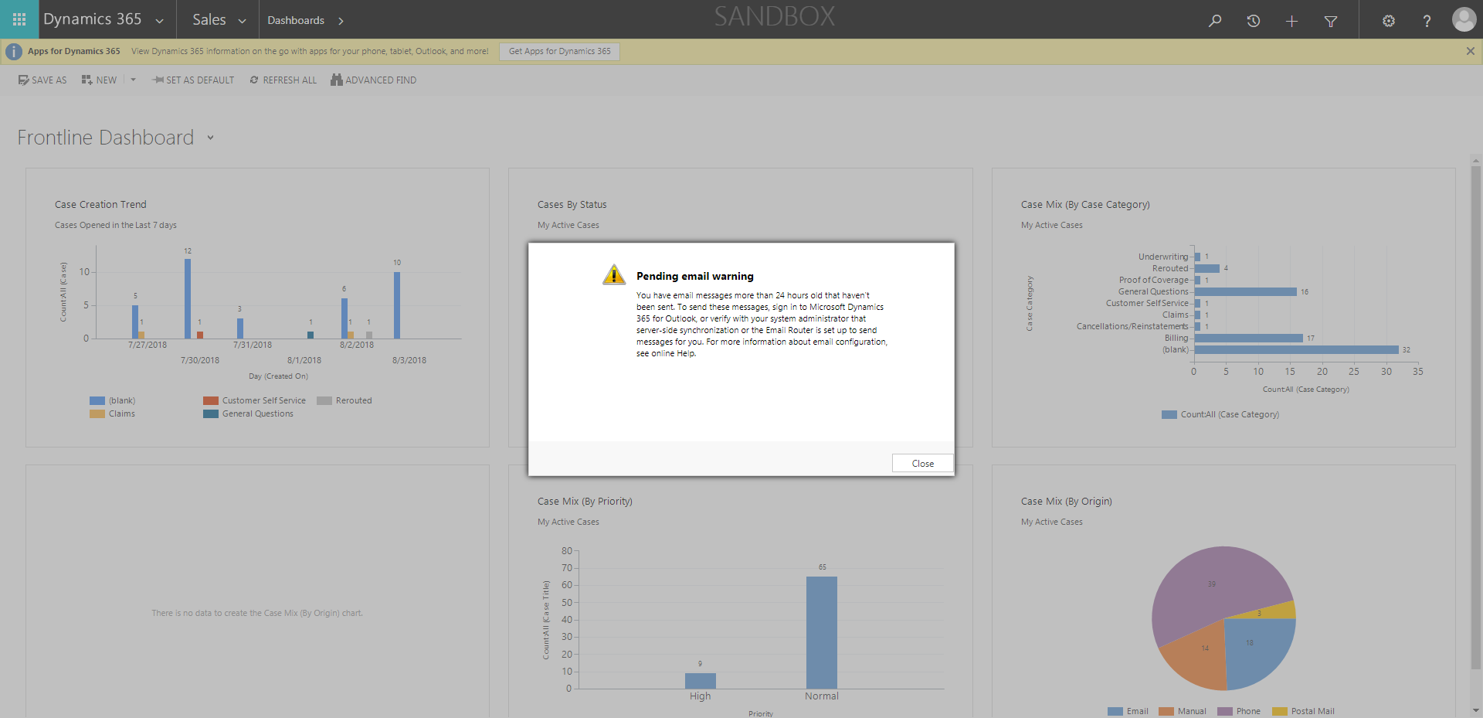

CaseManagement_CreationOfCase_Instance23_03-Aug-2018_06-06-02_AM_MouseClickActionMoveToElementBycssSelectoranavcases.png

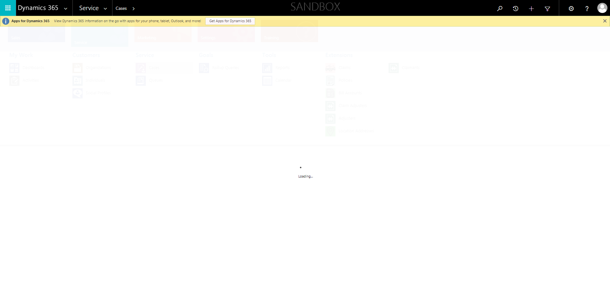

CaseManagement_CreationOfCase_Instance23_03-Aug-2018_06-06-56_AM_ValidatingCaseentitynavigation.png

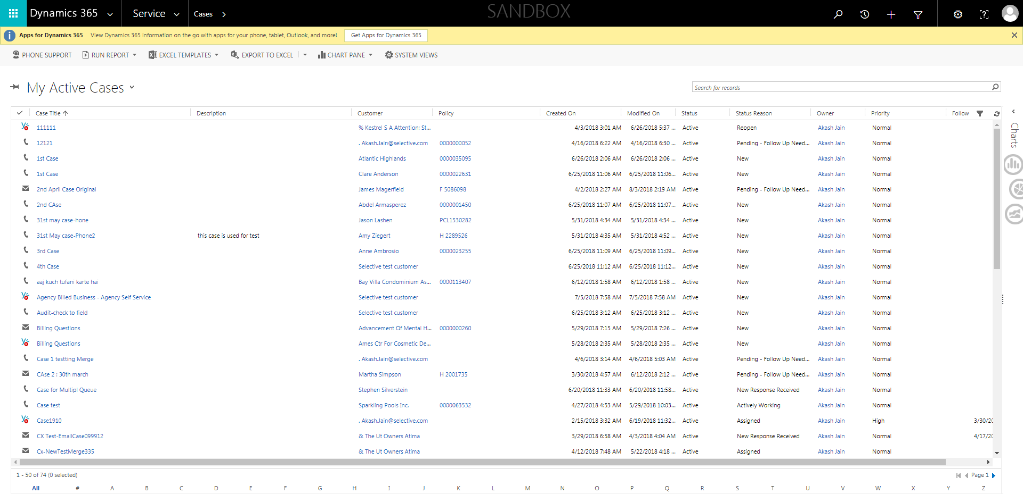

CaseManagement_CreationOfCase_Instance23_03-Aug-2018_06-06-00_AM_MouseClickActionMoveToElementBycssSelectorspanTabSFA.png

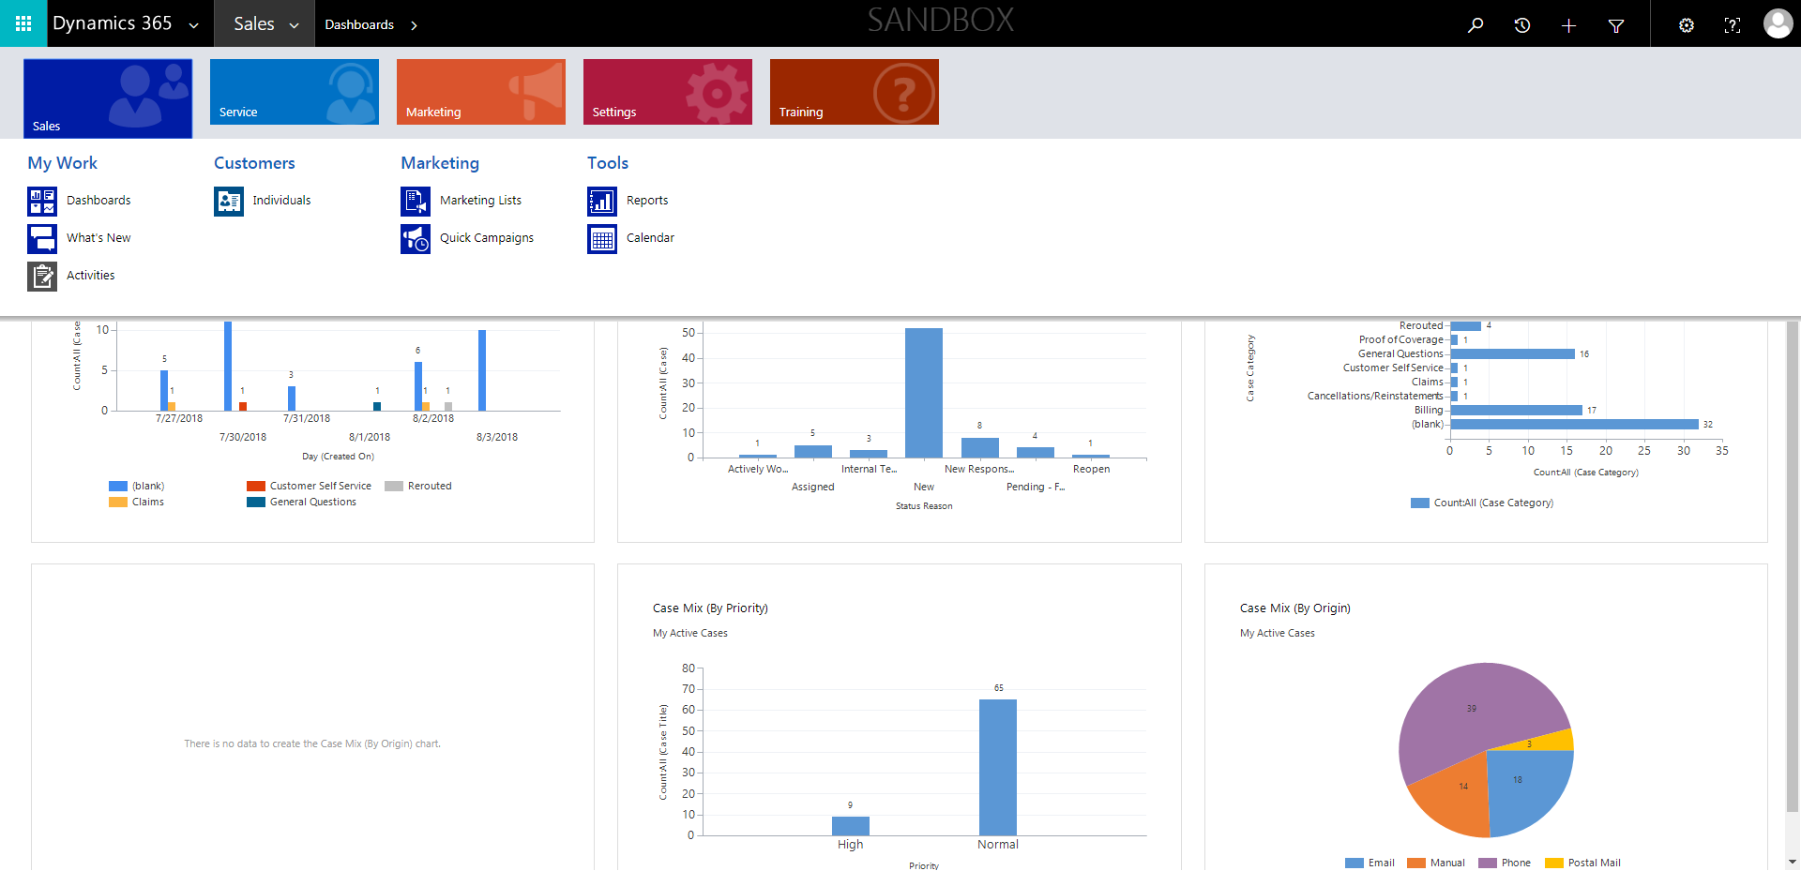

CaseManagement_CreationOfCase_Instance23_03-Aug-2018_06-06-55_AM_MouseClickActionMoveToElementBycssSelectoranavcases.png



CaseManagement_CreationOfCase_Instance23_03-Aug-2018_06-06-01_AM_MouseClickActionMoveToElementByxpathimgaltServiceparentspan.png

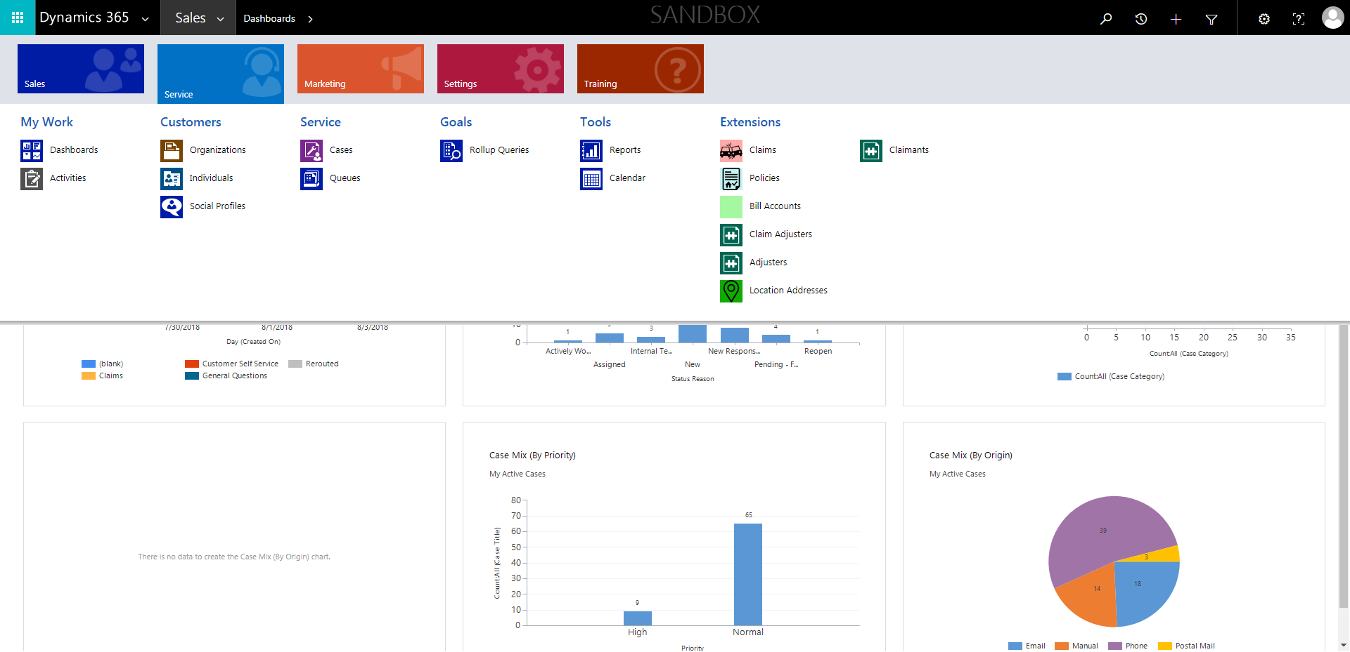

CaseManagement_CreationOfCase_Instance23_03-Aug-2018_06-06-53_AM_MouseClickActionMoveToElementByxpathimgaltServiceparentspan.png

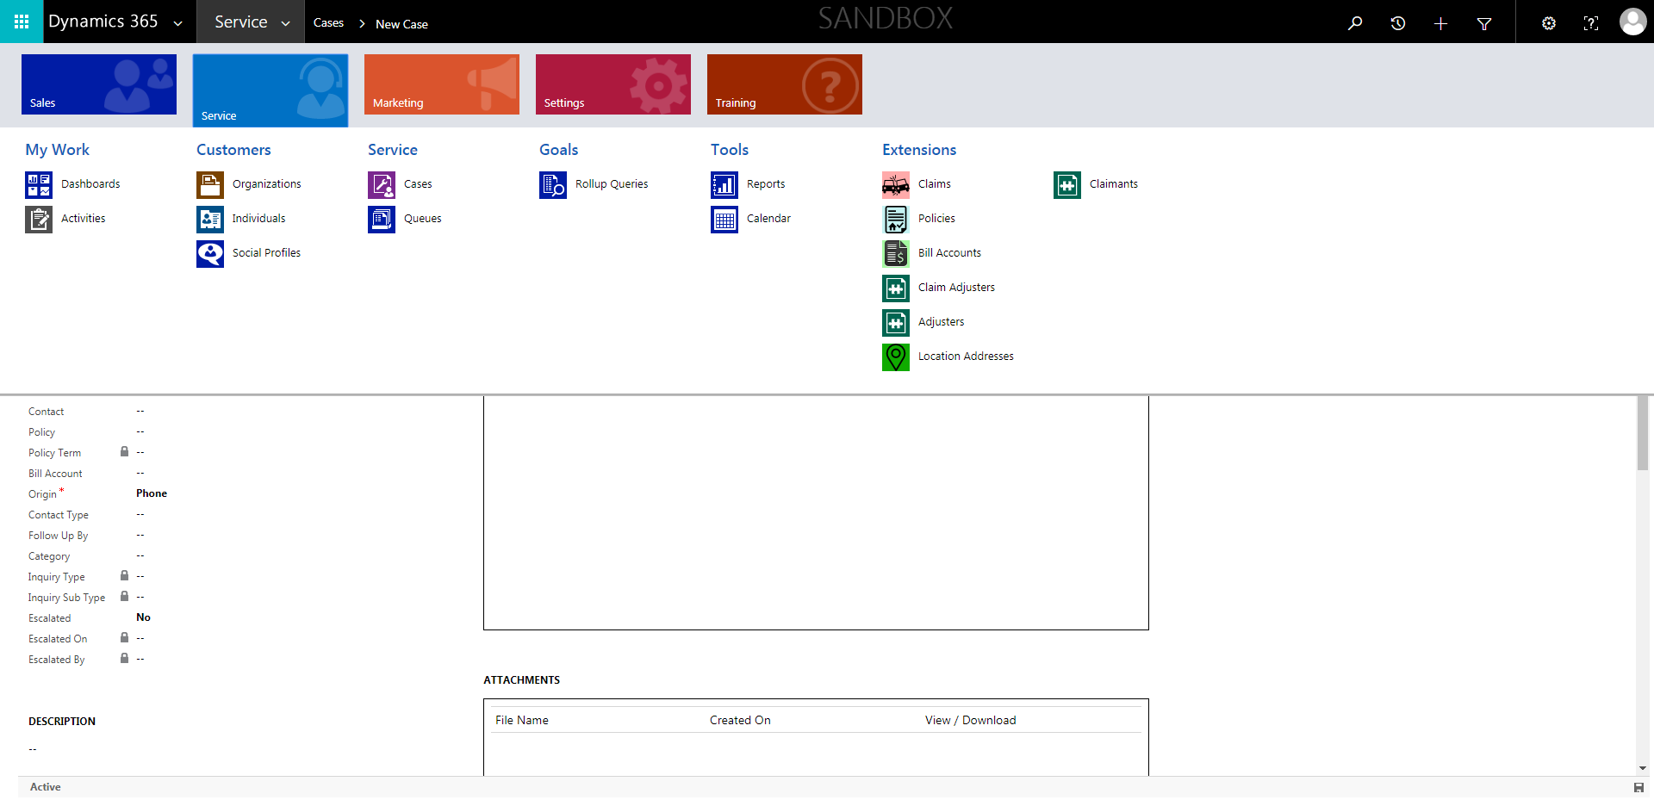

CaseManagement_CreationOfCase_Instance23_03-Aug-2018_06-05-28_AM_MouseClickActiononStaleElement.png

